- What is not true about computer architecture and organization?
  - One architecture may span many years
  - Technology change, architecture may be changed
  - Technology change, organization may be changed
  - The same organization have different series
  - All are not true
- What is not true about register?
  - One of major components in CPU
  - One kind of memory
  - Use as the storage device
  - Perform data processing
  - All are not true
- System interconnection provides the communication among what?
  - CPU, main memory, and peripheral devices
  - CPU, hard disk, and I/O
  - Processor, main memory, and I/O
  - Processor, Control, and I/O
  - All are true
- Personal computer used now has the same structure and function based on which one?
- Von Neumann Machine
- Alan Turing Machine
- IAS Computer
- ENIAC Machine
- All 1, 2, and 3 are true
- Which one is not true about the evolution of computer from the past until present?
- CPU speed is increase
- Computer size is decrease
- Memory capacity is increase
- I/O size is increase
- I/O speed is increase
- Which one is not true about IAS?
- General-purpose computer
- A binary machine
- Memory space has 1,000 address locations
- Each instruction uses 40-bit
- Instruction set contains 21 instructions
- What is the meaning of stored-program concept computer?
  - Program are stored in secondary memory
  - Data and instructions are stored in hard disk
  - Data and instructions are stored in RAM
  - Data and instructions are stored in Cache
  - Data and instructions are stored in CPU
- Which one can explain the best about microprocessor?
- Very small CPU
- Processor that has chip’s size in micro meter
- All of the processor components are on one chip
- All of the computer components are on a single chip
- All are true
- Which one explained the best about multiple cores?
- Multiple of memories in the system
- Multiple of processors in the system
- Multiple of memories on a single chip
- Multiple of processors on a single chip
- All are true
- What is the main reason that why the design is needed in computer system?
  - Decrease system cost
  - Balance the performance
  - Increase computer speed
  - Change architecture
  - Need smaller computer size
- If a computer has 22 bits address bus, what is the size of the maximum main memory of the system?
- 4 MBytes
- 32 MBytes
- 1024 MBytes
- 4096 MBytes
- No answer
- For figure on slide 17 (Chapter 3), what is the next instruction address in binary format to be fetched from main memory after step 6?
- 000000000001
- 001100000011
- 0000001100000100
- 0000000000000101
- No answer
- Why interrupt for I/O is used in a computer system?
- Priority of I/O is high
- Can execute many I/O instruction at the same time
- Instruction does not need to execute sequentially
- CPU can be used more efficiently
- I/O can execute instruction by themselves
- For figure on slide 30 (Chapter 3), if disk sent interrupt at t = 20 and the priority of disk is higher than the communication line, what time the interrupt service routine of communication line is completed?
  - t = 20
  - t = 25
  - t = 30
  - t = 35
  - No answer
- What is not true about PCI?
- One kind of bus
- First used by Intel
- Processor independent bus
- Use very small number of chips to produce
- Can be used on only single processor
Figure on slide 17 (Chapter 3), Use for No.12
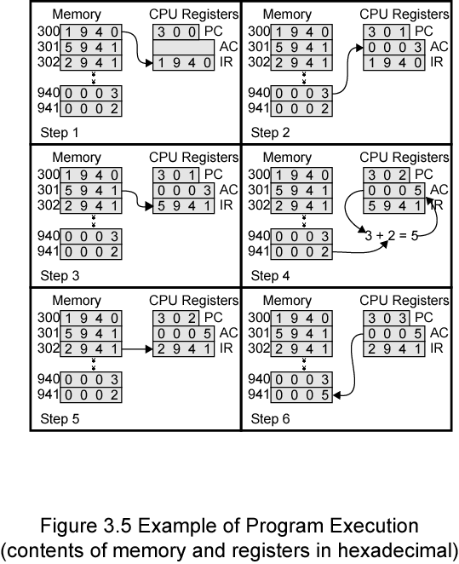

Figure on slide 30 (Chapter 3), Use for No.14

